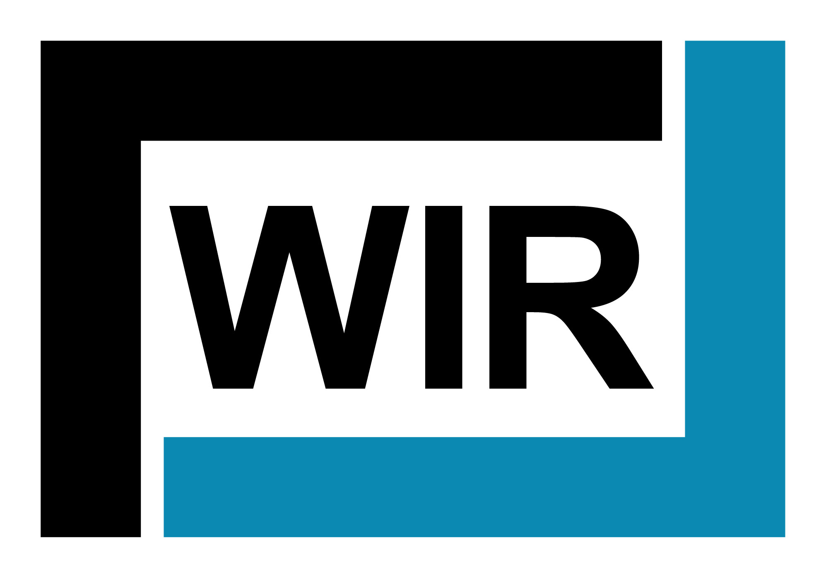
JOB VACANCY
Recruitment & Onboarding Coordinator
(Full-time, 40hrs/week)

Posting date: January 25, 2023

WIR Services Limited provides corporate services to a number of companies in the industrial construction, turnaround and maintenance markets across Western Canada. We are actively seeking a Recruitment & Onboarding Coordinator at our Calgary SE, AB location. Travel to project sites and other locations may be required from time to time. The Recruitment & Onboarding Coordinator will report directly to the Manager, Business Services or there designate.

Position Summary
The Recruitment & Onboarding Coordinator supports various HR functions in the WIR office as well as providing support to our Project teams as needed, in the areas of recruitment, onboarding, employee lifecycle documentation, training & development, compensation & Benefits, employee support, and other areas as needed. This position requires highly accurate and detailed acumen, high standard of confidentiality, and strong understanding of the employee lifecycle.

Duties & Responsibilities
- Full cycle recruitment including the development of job postings, postings jobs, resume’ screening, interviewing, and reference checks
- Coordinate employee changes through companies’ authorization process
- Prepare various types of employment change letters
- Track critical dates for employees and independent contractors
- Prepare employment contracts for a variety of employment types and independent contactors
- Prepare new and update existing HR forms and documents
- Coordinate onboarding for new employees including preparing onboarding materials, pre-employment testing, arranging new hire and safety orientation, and completion of new hire paperwork
- Schedule and present/participate in new employee orientations
- Maintain filing system for employee files, correspondence, policies, and standards in a highly confidential manner
- Administer benefits plan, including enrolments and administrative changes
- Create/revise position descriptions for various corporate and field roles
- Support the implementation and coordination of various HR programs/initiatives
- Receive and redirect HR related inquiries/calls and correspondence to the appropriate team member
- Assist in ad-hoc HR projects, including collection of employee feedback
- Provide support to employees for inquiries and requests
- Track policy and other HR renewal dates
- Complete administrative tasks upon request in a timely efficient manner
- Additional duties may be required in order to support the objectives of the company

Qualifications & Training
- Post-secondary Diploma or Certificate in Human Resources Management
- Effective communication and interpersonal skills
- High level of integrity, confidentiality and professionalism is required
- Strong attention to detail combined with a proven ability to multi-task and meet strict deadlines in a fast-paced environment
- Must be self-motivated and able to work individually and in a team environment
- Proven ability to handle and prioritize multiple tasks in a very busy environment
- Intermediate to advanced level of proficiency in all Microsoft office applications, including preparing and editing fillable forms

Experience & Skills
- Must have a minimum of 3 years of experience in full cycle recruitment
- Experience preparing employment contracts and various employment change letters
- Experience working within a HRIS (HR) system and providing support for HRIS (HR System) implementation is considered an asset
- Understanding of HR practices and concepts; HR management systems and software as well as HR tools and templates
- Flexible to meet and adapt to constantly changing demands of the workplace
- Powerful time management and organizational skills with a very high standard of attention to detail
- Knowledge of The Privacy Act with the ability to handle confidential & sensitive information appropriately
- Strong understanding of employee lifecycle and corresponding documentation

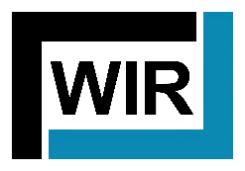

To apply, submit a cover letter and resume outlining how you meet the qualifications stated above.
All applications will be accepted on an equal basis.

ALL INTERNAL APPLICANTS MUST NOTIFY THEIR SUPERVISOR OF THEIR INTEREST AND INTENT TO APPLY.

We thank all applicants, but only those candidates selected for an interview will be contacted. Please forward your application prior to end of business day February 3, 2023 to:

Attn: WIR Services HR
11079 – 72 St. SE
Calgary, AB T2C 3G2
Email: wirhr@wirservices.ca

No Phone Calls Please

